
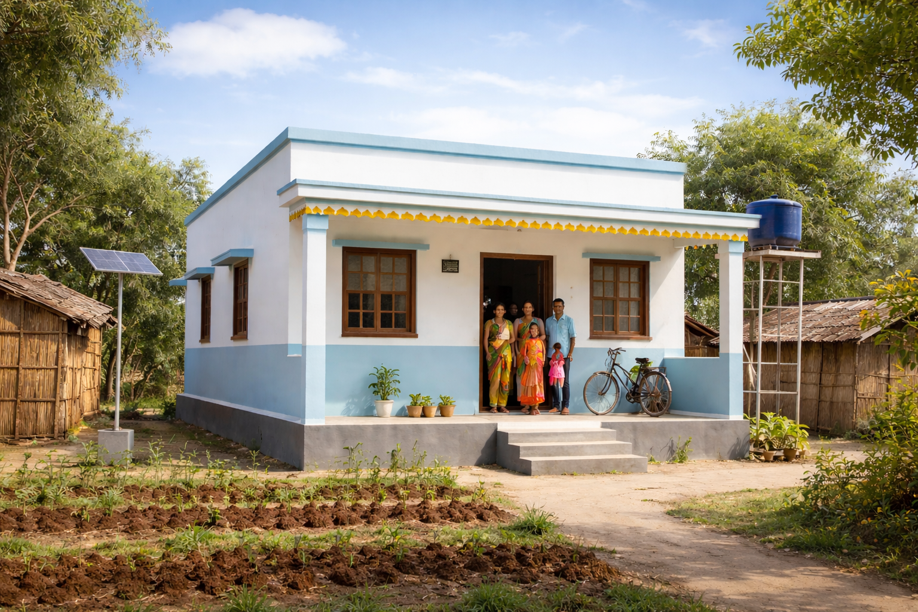
Prepared By: MASHAL (Maharashtra Social Housing and Action League)
FEASIBILITY REPORT
Housing Reconstruction Project for Flood-Affected Villages Hasnal & Ravangaon

TABLE OF CONTENTS

- Introduction……………………………………………………2
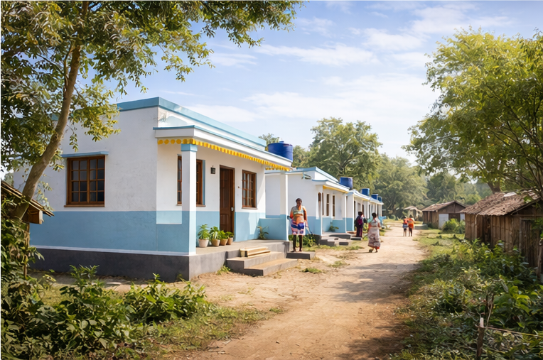
- Project Background……………………………………….3
- Need Assessment Summary……………………………8
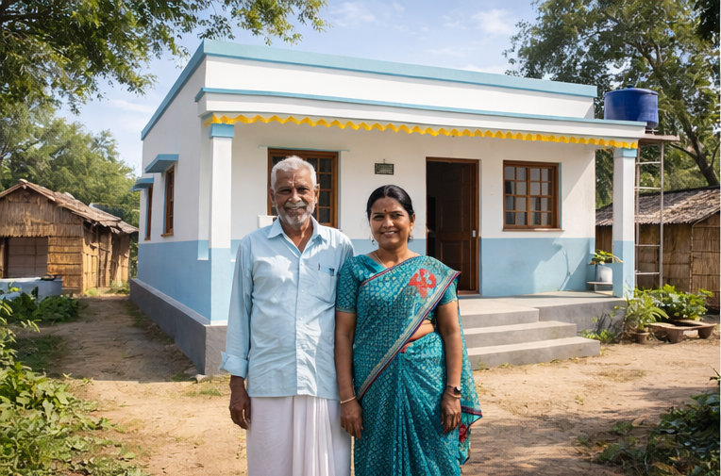
- Technical Feasibility……………………………………12
- Social Feasibility …………………………………………17
- Stakeholder Analysis……………………………………20
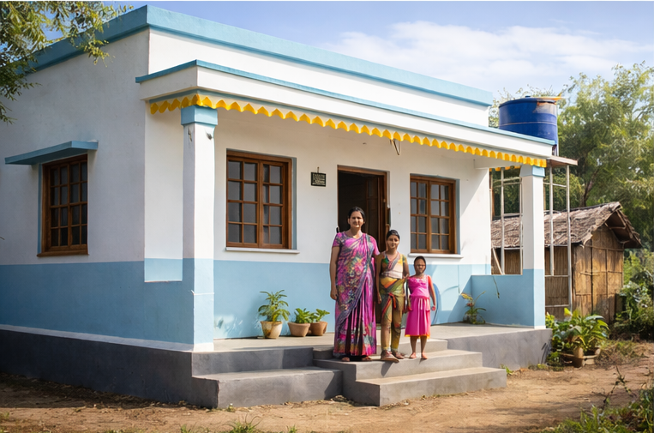
- Implementation Strategy ……………………………24
- Estimated Budget…………………………………………29
- Risks & Mitigation ……………………………………….32
10. Conclusion & Recommendation………………….35

Project Feasibility Report – Housing Reconstruction Support
- Introduction
Hasanal and Ravangaon are two remote agrarian villages situated along the Lendi River in Mukhed Taluka of Nanded District, Maharashtra. These villages form part of a drought-prone, economically vulnerable region where agriculture is the primary source of livelihood. Despite living with climate risks—including erratic rainfall, recurring droughts, and poor soil conditions—the communities have traditionally depended on farming to sustain their families.
On 18 August 2025, after a week of intense rainfall and unprecedented cloudbursts in the upper catchment areas of the Lendi River, both villages experienced one of the worst floods in their history. The water levels rose suddenly around 2:00 a.m., catching residents completely off guard. With no warning systems, evacuation protocols, or adequate infrastructure, the villages were entirely submerged within minutes.
The disaster resulted in:
- Loss of five lives, including three women.
- Extensive damage to homes, livestock, food grains, and agricultural fields.
- Destruction of essential community assets, including internal roads, drinking water systems, and electricity connections.
- Long-lasting psychological trauma, as families fled in darkness, carrying only their children and a few personal belongings.
The flooding was not merely a natural calamity but the outcome of 45 years of development stagnation, rooted in the incomplete Lendi Dam project announced in 1980. Since the declaration of the dam area, the government halted infrastructure funding for these villages under the assumption of future submergence. As a result:
- Residents lived without proper roads, schools, healthcare centres, drinking water systems, and mobile connectivity.
- Generations grew up without stable housing or livelihood security.
- Rehabilitation commitments remained unfulfilled or poorly executed.
Compensation announced in 1980 reached families two decades later, and even then, only the original household heads were recognized. Second- and third-generation members were excluded, leaving many without land rights or resources to rebuild homes.
In the aftermath of the 2025 flood:
- Approximately 240–248 families were displaced.
- The government established temporary shelters on nearby grazing lands, but these structures are inadequate for long-term living.
- Many families—especially small farmers, landless labourers, elderly residents, and widows—lack the financial capacity to rebuild permanent housing.
This feasibility report has been prepared to assess the technical, social, economic, environmental, and operational viability of implementing a CSR-supported Housing Reconstruction Project aimed at ensuring permanent, safe, and dignified housing for all flood-affected families in Hasanal and Ravangaon.
- Project Background

  - Overview of the Lendi River Flood Impact
The Lendi River, which serves as the lifeline for several villages in Mukhed Taluka, runs directly alongside Ravangaon and Hasanal. Over the years, the river has been known for seasonal fluctuations, but the event of 18 August 2025 was unprecedented in both scale and intensity. A rare combination of meteorological conditions—including heavy rainfall for seven consecutive days, simultaneous cloudbursts in multiple upstream pockets, and rapid accumulation of runoff water—caused the river to swell beyond its carrying capacity.
Despite partial closure of dam gates to regulate water flow, the sudden volume increase proved overwhelming. Between 1:30 a.m. and 2:00 a.m., the river breached its natural banks due to extreme hydraulic pressure and entered the villages at high speed. With no early warning mechanism, siren system, or flood preparedness infrastructure, residents were caught completely off-guard.
In a matter of minutes:
- Water levels rose rapidly, reaching waist to chest height inside homes.
- Families were forced to leave their belongings behind.
- Children, livestock, and elderly persons had to be evacuated in complete darkness.
The flooding persisted for several hours, causing widespread devastation that left both villages uninhabitable for days.
  - Key impacts included:
The disaster caused multidimensional damage affecting housing, livelihoods, and community safety. Key impacts include:
    - Complete Submergence of Both Villages: Floodwaters engulfed every residential area, agricultural plot, and internal road for several hours. The prolonged waterlogging weakened soil conditions and compromised structural integrity across the settlement.
    - Destruction of Housing: Most houses in Hasanal and Ravangaon were either kutcha (mud-based) or semi-pucca structures not designed to withstand intense water pressure. The flood caused:
- Collapse of walls
- Roof damage and displacement
- Foundation weakening
- Partial or complete structural failure
    - Loss of Household Assets: The water currents swept away:
- Grain stocks stored for the year
- Essential utensils, clothing, and bedding
- Livestock sheds and poultry units
- Stored seeds and agricultural inputs
- Sanitation structures such as latrines and soak pits
As a result, many families lost their entire household economy within a few hours.
    - Agricultural and Environmental Losses:
- Standing crops were destroyed in the kharif season.
- Soil erosion removed the top fertile layer.
- Silt deposition has made some fields temporarily unusable.
- Farmers face a long recovery period before restoring productivity.
    - Emergency Displacement
Families fled to nearby hilltops and higher ground during the night.
Children, elderly, and livestock were carried through strong currents, causing significant trauma.
    - Human Casualties and Psychological Impact
- Five deaths, including three women, were officially recorded.
- Many residents experienced severe emotional distress due to sudden displacement.
- The fear of future flooding remains high among all households.
  - Details of the Affected Villages
1. Ravangaon
- Population: ~2,389
- Households: Approximately 292
- Livelihoods: Primarily agriculture (cotton, soybean, moong, urad, gram)
- Geographical Vulnerability:
  - Settlement located in low-lying depressions near the river
  - Houses packed closely with narrow internal roads
- Impact Pattern:
  - Downstream water flow caused direct entry into homes
  - Majority of houses experienced structural damage
2. Hasanal (Hasanala)
- Population: ~1,151
- Households: Approximately 275
- Settlement Pattern:
  - Houses built along the banks and foothills of the Lendi River
  - Many structures built without planned drainage pathways
- Impact Pattern:
  - Initial surge of water struck Hasanal first
  - Displacement was quicker and more chaotic
  - Vulnerable families (widows, elderly, disabled) suffered the most
  - Pre-Existing Infrastructure Gaps
Both villages were already highly vulnerable even before the flood due to decades of development neglect linked to the dam project. The absence of basic infrastructure amplified the scale of damage.
    - Critical Gaps Identified:
- All-weather Roads:
Poor road connectivity impeded evacuation and delayed relief supply movement.
- Reliable Drinking Water Systems:
Dependence on seasonal wells and handpumps meant no safe water post-flood.
- Sanitation Units:
Most toilets were either kutcha structures or absent entirely, leading to contamination risks.
- Primary Healthcare Facilities:
Absence of medical centers meant no immediate care for injuries, snakebites, or infections.
- Electricity Stability:
Long-term power outages were reported; local transformers remained submerged.
- Mobile Network Coverage:
Communication failures prevented timely warning and coordination.
    - Conclusion:
The disaster exposed deep infrastructural inequalities and increased the urgency for permanent rehabilitation and resilient housing construction.
  - Total Families Affected: 248
    - A collaborative household-level assessment was conducted by:
- Gram Panchayat members
- Village development committees
- SSM & MASHAL field teams
- Local youth groups and volunteers
- Community-led verification mechanisms
Through this comprehensive process, 248 households were officially identified as directly affected by the flood.
    - Categories of Affected Families:
- Families with Fully Damaged Houses
  - Structures completely collapsed or swept away
  - Require total reconstruction support
- Families with Partially Damaged but Unsafe Houses
  - Houses standing but unsafe for occupation
  - Needs major repair or rebuilding
  - Currently living in makeshift camps
- Landless Labour Families
  - Dependent entirely on agricultural labour
  - No land or assets to rebuild independently
  - Highly vulnerable to livelihood shocks
- Widow and Women-Headed Households
  - Limited earning capability
  - Urgent need for safe housing for children
- Elderly and Differently-Abled Beneficiaries
  - Require priority support
  - At high risk from climate-related events
    - Current Living Conditions
- Families are staying in temporary shelters built on grazing land.
- Shelters are made of tin sheets or tarpaulin, prone to heat, wind, and rainfall.
- No proper flooring, cooking area, or sanitation facilities.
- Risk of health issues such as infections, snake bites, and water contamination is high.
- Women and children face safety, privacy, and hygiene challenges.
    - Conclusion:
Given the extremely poor living conditions and absence of financial recovery capacity, the affected 248 families urgently require permanent, resilient, and dignified housing solutions.

- Need Assessment Summary
The flood of 18 August 2025 exposed deep-rooted vulnerabilities in Hasnal and Ravangaon, affecting housing, livelihoods, safety, and long-term community stability. The need assessment undertaken by MASHAL, in coordination with Gram Panchayat representatives, community leaders, and residents, provides a comprehensive understanding of the rehabilitation priorities.
  - Extent of Housing Damages
The housing stock in both villages comprised predominantly kutcha structures (mud & stones) and semi-pucca houses (brick walls with tin roofs). These structures were not engineered to withstand sudden flooding or high-velocity water currents.
    - Major observations include:
1. Fully Damaged Houses – 91%
- Walls collapsed or washed away due to water pressure.
- Foundations eroded, making reconstruction on the same site unsafe.
- Roofs blown off or submerged, causing complete structural failure.
- Household items such as utensils, clothing, educational materials, beds, and agricultural tools washed away.
2. Partially Damaged but Unsafe Houses – 9%
- Deep cracks in walls, bent steel sections, damaged flooring.
- Roofs partially collapsed or destabilised.
- Houses cannot be repaired cost-effectively; safe repair is not feasible.
- Continuous dampness has weakened structural components.
3. No House Found Liveable
- Even the least affected houses have been compromised by water ingress.
- All families are presently residing outside their homes.
4. Damage to Household Assets
- Livestock sheds collapsed or filled with debris, resulting in:
  - Death of goats, poultry, and small animals.
  - Loss of cattle feed and fodder.
- Grain storage drums and sacks were destroyed by floodwater.
- Essential identity documents (ration cards, Aadhaar, land records) were damaged or lost.
- Sanitation units were washed away or left in unusable condition.
- Internal electrical wiring and meters were destroyed due to immersion.
    - Impact:
The complete loss of physical, financial, and livelihood assets has pushed families into extreme vulnerability, making external support essential for recovery.
  - Vulnerable Population
Out of the 248 affected households, several categories require priority in rehabilitation due to socio-economic fragility:
    - Widow-Headed Families
- Limited earning capability.
- No adult male support for labour-intensive rebuilding.
- High dependence on external assistance.
    - Elderly Residents Living Alone
- Physically unable to participate in reconstruction activities.
- Higher health risks due to exposure to elements in temporary shelters.
    - Persons with Disabilities (PWD)
- Require housing designed with accessibility features.
- Lost assistive devices during the flood.
    - Landless Labour Families
- Dependent solely on daily wage income.
- No savings or assets; reconstruction is impossible without support.

    - Women-Headed Households with Children
- Often juggling caregiving responsibilities with labour work.
- Require safe, secure housing for children's safety and development.
    - Marginal Farmers (Less than 1 acre)
- Major crop loss has eliminated their seasonal income.
- Cannot invest in reconstruction due to agricultural instability.
    - Conclusion:
These vulnerable groups require immediate, prioritized, and tailored support within the housing project.
  - Immediate Needs
The immediate post-flood needs focus on ensuring survival, safety, and stabilization of affected families. These include:
    - Safe Temporary Shelters
- Current shelters are made of tarpaulin or tin sheets with no ventilation.
- Need weather-resistant transitional shelters until permanent housing is ready.
    - Drinking Water Supply
- Wells and hand-pumps are contaminated with silt and sewage.
- Urgent need for purified drinking water to prevent waterborne diseases.
    - Food Security
- Loss of grain storage and standing crops has led to food scarcity.
- Dependence on relief supplies will continue for weeks.
    - Proper Sanitation Units
- Lack of functional toilets increases the risk of infections, especially among women and children.
- Open defecation is unsafe due to debris, snakes, and contamination.

    - Electricity Connection
- Power supply remained disrupted for days due to submerged transformers.
- Urgent need for lighting and power for communication.
    - Medical & Psychological Support
- High risk of fever, infections, and skin diseases.
- Psychological trauma, especially among children, requires attention.
    - Protection from Seasonal Hazards
- Rainfall, cold weather, and wind affect temporary shelters severely.
- Families remain exposed to natural elements.
  - Long-Term Rehabilitation Needs
Long-term recovery requires a holistic and sustainable approach, focusing not only on housing but also on the socio-economic revival of the communities.
    - Permanent, Disaster-Resilient Housing
- Houses must include raised plinths, RCC frames, durable walls, and proper drainage.
- Designs should consider future flood risk to reduce recurring damages.
- A standardized model will ensure quality, cost-efficiency, and safety.
    - Secure Land Tenure
- Many families lack formal land titles due to generational displacement.
- Securing tenure ensures legal protection and enables access to government schemes.
    - Restoration of Livelihoods
- Floods damaged:
  - Standing crops
  - Stored seeds
  - Livestock
  - Agricultural tools
- Interventions needed:
  - Seed and tool kits
  - Livestock support
  - Soil reclamation efforts
    - Access to Healthcare and Education
- Lack of nearby healthcare facilities worsened the impact of the flood.
- Primary schools require repair or strengthening.
- Community health outreach is essential to prevent post-disaster diseases.
    - Community Infrastructure Improvement
To ensure long-term resilience, the villages require:
- All-weather internal roads
- Proper drainage systems
- Public water storage tanks and pipelines
- Solar or grid-based street lighting
- Waste management systems
- Preparedness and early-warning mechanisms
    - Conclusion:
Addressing these long-term needs through a structured CSR-supported housing and rehabilitation program will help restore stability, dignity, and safety to the affected families and strengthen community resilience against future disasters.
- Technical Feasibility
The technical feasibility assessment evaluates whether the proposed housing reconstruction project can be successfully implemented from an engineering, land, environmental, and infrastructure perspective. A comprehensive analysis conducted by MASHAL’s technical team, along with local authorities, indicates that the project is technically sound, feasible, and implementable with moderate preparatory work.

  - Availability of Safe Land
Following the flood, the Gram Panchayat and district administration jointly conducted a land assessment to identify safe relocation sites for affected families. The following findings ensure feasibility:
    - Safe and Elevated Locations
- The identified land parcels are situated on higher elevation levels compared to the original settlement areas, reducing the probability of future flooding.
- Elevation studies show that the land slopes naturally towards open drainage zones, improving rainwater runoff.
    - Outside the Flood-Prone Zone
- The proposed relocation sites fall outside the Lendi River's historical flood path.
- These areas have not experienced river overflow even during heavy rainfall in previous years.
    - Adequate Land Availability
- On-ground measurements and GPS-based mapping confirm that the land parcels are sufficient to accommodate cluster-based housing layouts for all 240–248 families.
- Land demarcation can support:
- 150–250 sq. meter plots,
- Internal lanes,
- Community amenities,
- Space for essential services such as water tanks, electricity transformers, and open areas.

    - Administrative Readiness
- Gram Panchayat and Tehsildar have expressed readiness to expedite:
- Mutation entries
- Beneficiary lists
- Land allocation procedures
- This supports legal clarity and construction commencement.

    - Conclusion: Land suitability and availability strongly support project viability.
  - Construction Feasibility
A technical evaluation of soil, material availability, construction technology, and housing design was undertaken.
    - Soil Suitability
- Soil tests (visual & manual inspections) indicate:
- Moderate-density, stable soil suitable for shallow foundations.
- No evidence of excessive clay content or rock plate that would obstruct base construction.
- Suitable for single-storey RCC-framed or composite structures.
    - Material Availability
Essential construction materials are available locally:
- Bricks and hollow blocks accessible from Mukhed and Nanded areas.
- Cement, steel, sand, and aggregates easily transported from nearby suppliers.
- Local skilled and unskilled labour available, reducing labour cost and mobilization time.
    - Viability of Low-Cost Housing Models
- A cost-effective design integrating:
- RCC plinth and columns
- Brick/block walls
- Weatherproof roofing
- Ventilated windows
- Basic flooring
- Attached sanitary space
- Modular nature allows families to expand the structure once economically stable.
    - Disaster-Resilient Construction Features
- 1.5 to 2-feet raised plinths to prevent rainwater entry.
- RCC lintel and ring beams to increase structural stability.
- Sloped roofing or RCC slab with waterproofing for rain safety.
- Use of anti-corrosion steel to improve building longevity.
    - Conclusion: The construction of durable, low-cost, and climate-resilient homes is technically achievable within the available resources.
  - Infrastructure Readiness
While the housing structures can be constructed, the relocation site requires essential external infrastructure. These elements can be integrated through coordination with Gram Panchayat, district authorities, and available government schemes.
    - Internal Access Roads
- The current terrain requires grading and compacting for internal pathways.
- Construction of WBM (Water Bound Macadam) or CC (Cement Concrete) roads will ensure durable connectivity.
    - Drainage Channels
- Proper stormwater drainage is essential to mitigate waterlogging.
- Open-lined drains along the internal roads will channel water safely away.
    - Electricity Infrastructure
- Installation of electricity poles, household connections, and transformers is necessary.
- State electricity department has indicated readiness to support new settlement electrification.
    - Drinking Water Supply
- Implementation of:
- Central community water tank
- Borewell/water pipeline connection
- Household tap connections under Jal Jeevan Mission

    - Sanitation & Waste Management
- Construction of twin-pit or septic-tank sanitation systems aligned with Swachh Bharat Mission.
- Designated waste collection points for village waste management.
    - Government Scheme Convergence
Infrastructure development can leverage:
- PMAY (Pradhan Mantri Awas Yojana) Rural for housing subsidy
- Jal Jeevan Mission for water supply
- Swachh Bharat Mission (Gramin) for sanitation
- Gram Panchayat rural funds/15th Finance Commission for streetlights, drains, and internal roads
    - Conclusion: Infrastructure development is feasible with convergence support and minimal civil engineering interventions.
  - Environmental Risk Analysis
A comprehensive environmental review was conducted to ensure that the proposed housing sites are safe and sustainable in the long term.
    - Flood Safety
- New sites are located at higher elevation and outside the natural floodplain.
- Proximity to water drainage channels is safe with adequate buffer zones.
    - No Ecologically Sensitive Areas
- No involvement of:
- Forest land
- Wildlife habitats
- Coastal Regulation Zone (CRZ)
- Environmentally restricted areas
- This simplifies compliance procedures.
    - Climatic and Seasonal Considerations
- The region experiences heavy monsoon rain; hence:
- Raised plinths
- Waterproof roofing
- Peripheral drainage are recommended to mitigate environmental stress.

    - Sustainability Measures
- Opportunities for:
- Rainwater harvesting
- Groundwater recharge pits
- Solar lighting for common areas
- These will improve resilience and reduce long-term environmental impact.
    - Conclusion: Environmental risks are low, manageable, and can be mitigated with proper site planning.
  - Conclusion
The technical feasibility review demonstrates that the proposed housing reconstruction project for Hasnal and Ravangaon is practical, safe, and implementable. Land availability, construction viability, infrastructure integration, and environmental safeguards are all favourable. With appropriate planning and phased execution, durable, low-cost, and disaster-resilient houses can be constructed successfully for the 248 flood-affected families.
The project is therefore technically feasible, requiring only manageable preparatory work and coordinated infrastructure support.
- Social Feasibility
Social feasibility assesses whether the affected communities of Hasnal and Ravangaon are willing, prepared, and socially capable of participating in and sustaining the proposed housing reconstruction project. The observations collected through MASHAL’s community meetings, FGDs (Focus Group Discussions), and household surveys show a high level of acceptance, urgency, and readiness among residents.
  - Community Willingness
    - Strong Desire for Permanent Housing
The disaster has left all 248 affected families in temporary shelters with limited dignity, privacy, and safety. During consultations, community members expressed a strong and urgent desire to transition into stable, permanent homes.
    - Active Participation in Assessments
- Families cooperated actively in the need assessment surveys conducted by MASHAL and Gram Panchayat teams.
- Residents openly shared details of losses, vulnerabilities, and household-specific needs.
- People participated in group meetings despite challenging conditions in the transit shelters.

    - High Willingness for Contribution
The community has shown readiness to contribute through:
- Shramdaan (voluntary labour) such as clearing land, assisting in masonry, or transporting materials.
- Local resource contributions, including sand, stones, or small local materials available nearby.
- Community monitoring and supervision, which supports transparency and improves accountability.
    - Collective Responsibility Mindset
The disaster has strengthened community unity. Families are willing to work together in:
- Organizing labour
- Supervising quality of construction
- Ensuring fair beneficiary selection
- Maintaining community infrastructure post-construction
    - Conclusion: The strong motivation to rebuild and willingness to participate significantly increase the project's social feasibility and long-term sustainability.
  - Land Ownership & Tenure Clarity
    - Government-Allotted Land for Rehabilitation
- The Gram Panchayat, in coordination with the Tehsildar’s office, has earmarked specific land parcels for construction of new housing clusters.
- This land is under government control, simplifying allocation, documentation, and approval processes.
    - Beneficiary Identification Process
To ensure fair and transparent housing allocation:
- The Gram Panchayat is updating a verified list of genuine flood-affected families, with support from MASHAL.
- Duplicate entries are being screened out through cross-verification with community representatives.
- Priority lists (widows, elderly, PWDs, landless families) are being prepared to guide equitable allocation.
    - Documentation & Tenure Allocation
Beneficiary documentation is being aligned with:
- District administration norms
- Revenue department guidelines
- Village-level land allocation processes
Where needed, MASHAL will support families with:
- Replacing lost ID documents
- Completing formal applications
- Accessing government support schemes like PMAY Rural (if criteria allow)
    - Legal Security for Families
Ensuring land tenure will:
- Provide long-term protection from eviction
- Enable families to invest in expanding or upgrading their homes
- Allow access to future government welfare schemes
    - Conclusion: Clear land tenure pathways and administrative cooperation significantly enhance the project’s social feasibility.
  - Local Labour Availability
    - Availability of Skilled and Unskilled Labour
- The region has a strong availability of local masons, carpenters, and labourers, primarily engaged in rural construction work.
- Many residents possess construction-related skills due to migration experience in cities like Mumbai, Pune, and Hyderabad.
    - Leveraging Local Labour Strength
Using local labour:
- Reduces overall project cost
- Speeds up construction due to familiarity with local soil and materials
- Improves community ownership of the project
- Enhances quality due to accountability and trust among residents
    - Addressing Skill Gaps
- For specialized tasks (RCC framework, plumbing, electrical work), additional skilled labour from Nanded, Latur, and Mukhed can be mobilized.
- Contractors from these towns have shown readiness to collaborate.
    - Women’s Participation
- Women’s Self-Help Groups (SHGs) have shown interest in participating through:
- Material supervision
- Cooking for labour teams
- Keeping site records
- Monitoring construction progress
- This strengthens community cohesion and empowerment.
    - Youth Involvement
- Local youth groups expressed readiness for physical labour and site management support.
- They are willing to help in:
- Basic construction tasks
- Labour mobilization
- Monitoring and logistics
    - Conclusion: The presence of a ready workforce and the willingness of the community to engage in the construction process make the project socially robust and implementable.
    - Overall Conclusion on Social Feasibility:
The housing reconstruction project in Hasnal and Ravangaon has strong social acceptance, readiness, and active community participation. Clear land allocation, community willingness, and accessibility of local labour collectively make the project socially viable and sustainable. Community ownership will also ensure long-term upkeep, maintenance, and resilience of the housing settlement.
- Stakeholder Analysis
The success of the housing reconstruction project for Hasnal and Ravangaon depends on the coordinated efforts of multiple stakeholders, including government departments, local leaders, and community institutions. Understanding their roles, responsibilities, and influence helps ensure smooth project execution, effective conflict resolution, and long-term sustainability.
  - Government Departments
Government authorities play a crucial role in the legal, administrative, infrastructural, and technical aspects of the project. Each department’s cooperation is essential for land approval, documentation, and infrastructure integration.
    - District Collector Office – Nanded
- Provides overall administrative approval, clearance, and policy direction.
- Facilitates inter-departmental coordination during project implementation.
- Oversees monitoring and ensures compliance with district-level rehabilitation policies.
- Can help integrate the project with government schemes (e.g., PMAY Rural, JJM, SBM).
    - Tehsildar Office – Mukhed
- Responsible for land documentation, mutation entries, and survey verification.
- Confirms legal eligibility of beneficiaries, especially those lacking formal land titles.
- Helps streamline land allocation for a cluster-based housing settlement.
    - Rural Development Department (RDD)
- Provides alignment with village development schemes and rural housing guidelines.
- Supports integration of:
- PMAY Rural housing subsidies
- Infrastructure funds under 15th Finance Commission
- MGNREGA for labour-intensive tasks (if applicable)

- Ensures standards for rural housing and amenities are met.
    - Public Works Department (PWD) & Zilla Parishad (ZP)
- Offers technical and engineering support for roads, drainage, and public infrastructure.
- Helps design and construct internal access roads and culverts.
- Supports village-level development planning and approvals.

    - Electricity Department (MSEDCL or equivalent)
- Provides new electrical poles, wiring, transformers, and metered household connections.
- Ensures the settlement receives stable and safe electricity supply.
- Monitors safety norms for electrical infrastructure in the new layout.
    - Irrigation Department
- Critical stakeholder due to the Lendi Dam project.
- Ensures construction activity does not conflict with future dam work.
- Provides flood history data and technical inputs for risk mitigation.
- Coordinates with MASHAL regarding safe zones and long-term hydrological risks.
    - Conclusion: Government departments will play a central role in approvals, land provision, infrastructure creation, and monitoring, making their involvement crucial for the project's success.
  - Local Political Influencers
Local political leaders and elected representatives influence community decision-making and can either facilitate or obstruct project progress. Engaging them proactively ensures smoother execution.
    - Gram Panchayat Leadership
- Acts as the primary interface between the community and government agencies.
- Validates beneficiary lists, resolves disputes, and supports mobilization.
- Provides land-related resolutions, permissions, and community endorsement.
- Ensures Panchayat-level services like water, sanitation, and streetlights are incorporated.
    - Local MLAs/MPs
- Their support is important for:
- Escalation of pending approvals
- Mobilization of additional government funds
- Political backing for smooth project execution
- Can help fast-track administrative processes during rehabilitation.
    - Village Development Committees (VDCs)
- Influence decision-making at the grassroots level.
- Ensure community participation and consensus building.
- Help intervene in conflicts, grievances, and disagreements within the community.
Importance of their Support
- Ensures smooth implementation without resistance.
- Helps maintain transparency and equitable distribution of benefits.
- Strengthens community trust in the project and reduces political interference.
    - Conclusion: Political influencers serve as critical partners who can facilitate permissions, expedite approvals, and support community mobilization.
  - Community Groups
Community institutions and informal groups form the backbone of on-ground execution. Their active involvement ensures sustainable, community-owned implementation.
    - Self-Help Groups (SHGs)
- Actively support:
- Household-level data collection
- Monitoring of construction quality
- Facilitating communication between families and project teams
- Women-led SHGs help ensure transparency and empower female beneficiaries.
    - Farmers’ Collectives
- Provide insights into agricultural losses and livelihood restoration needs.
- Assist in planning for livestock sheds, storage spaces, and safe agricultural zones in the new layout.
- Mobilize local resources such as sand, stones, and surplus farm material.
    - Youth Groups
- Offer strong physical labour support for construction and site preparation.
- Help with logistics, material movement, and infrastructure creation.
- Provide volunteer manpower for cleanliness drives and community awareness.

    - Village Disaster Committees (VDCs)
- Play a key role in:
- Identifying vulnerable families
- Coordinating relief and emergency support
- Ensuring compliance with village safety norms
- Maintaining a long-term disaster preparedness plan

    - Community Responsibilities
The collective roles of these groups include:
- Beneficiary Verification: Ensuring fairness in beneficiary identification and allotment.
- Labour Mobilization: Helping arrange local labour to reduce costs and speed up construction.
- Social Monitoring: Overseeing progress, quality of work, and grievance handling.
- Conflict Resolution: Addressing any disputes related to land, resources, or construction sequence.
    - Conclusion: Community institutions serve as strong social anchors, helping create an inclusive, transparent, and accountable implementation environment.
    - Overall Conclusion for Stakeholder Analysis
The involvement of government departments, political leaders, and strong community groups collectively enhances the feasibility of the project. Their coordinated efforts will ensure faster approvals, community buy-in, effective mobilization, timely implementation, and long-term sustainability of housing for flood-affected families.
- Implementation Strategy
The housing reconstruction project for Hasnal and Ravangaon requires a structured, systematic, and community-inclusive implementation approach. The strategy focuses on phased execution, transparent beneficiary prioritization, and robust monitoring to ensure quality, accountability, and timely delivery. The following framework outlines the operational roadmap for successful project implementation.
  - Phasing of Construction
Implementation will be carried out in three systematic phases to ensure smooth execution, quality assurance, and stakeholder coordination.

    - Phase 1: Preparatory Work (1 Month)
This foundational phase ensures administrative readiness, technical clarity, and beneficiary finalization before physical construction begins.
Key Activities:
- Final Beneficiary Listing
- Verification of 248 flood-affected households based on criteria established by the Gram Panchayat and MASHAL.
- Prioritization of vulnerable groups (widows, elderly, PWD, landless labourers).
- Public display of final list to ensure community transparency.
- Land Survey & Site Preparation
- Detailed topographical survey of the allocated land parcels.
- Demarcation of individual plots and common areas.
- Clearing debris, leveling ground, and preparing access paths for material transport.
- Layout Design Finalization
  - Preparation of a cluster-based housing layout considering:
    - Ventilation and sunlight
    - Open spaces and pedestrian safety
    - Drainage pathways
    - Placement of community facilities (water tanks, transformers, open areas)
- Review and approval by technical engineers and Gram Panchayat.

- Procurement of Materials
- Tendering and vendor selection through transparent procurement processes.
- Bulk purchase of cement, bricks, steel, sand, and aggregates to reduce cost.
- Establishment of temporary storage yards near the site.

    - Phase 2: Construction (5–6 Months)
This is the core phase of the project, involving sequential and monitored construction activities.

Key Activities:
- Plinth Construction
  - Excavation of foundations based on approved design.
  - Construction of RCC foundations and raised plinth (1.5–2 feet) for flood resilience.
  - Soil compaction and waterproofing treatment.
- House Superstructure
  - Brick or block masonry walls.
  - RCC columns, beams, and lintel construction.
  - Installation of doors, windows, and internal support structures.
- Roofing & Sanitation Unit
  - Cost-effective roofing solutions (RCC slab or sloped GI sheets based on design).
  - Construction of attached sanitation units with septic tanks or twin pits.
  - Basic plumbing and electrical conduits installation.
- Internal Pathways Development
  - Construction of internal CC/WBM roads depending on funds and terrain.
  - Creation of drainage channels along pathways to avoid future waterlogging.
    - Phase 3: Completion & Handover (1 Month)
This final phase ensures quality completion, community readiness, documentation, and reporting.
Key Activities:
- Quality Checks
  - Thorough inspection by MASHAL’s engineering team.
  - Verification of materials, workmanship, structural integrity, and sanitation units.
  - Rectification of defects (if any).
- Community Orientation
  - Orientation sessions on:
    - House maintenance
    - Wastewater disposal
    - Sanitation practices
    - Disaster preparedness
  - Awareness on safe electrical usage and water conservation.
- Handover Documentation
  - Issuance of house handover certificates.
  - Photographic documentation for CSR records.
  - Entry of beneficiary details into Panchayat records.
- CSR Reporting
  - Submission of progress reports, financial statements, and completion documents.
  - Final impact summary shared with CSR partners.
  - Beneficiary Prioritization
A transparent and fair method for beneficiary selection is critical to ensuring equity and community trust. The project adopts a clear prioritization mechanism based on vulnerability and extent of damage.
    - Priority Categories:
- Families with Fully Damaged Houses
  - Immediate need for permanent shelter due to total loss of housing.
- Widows, Elderly, and Persons with Disabilities (PWD)
  - Socially and physically vulnerable; require urgent and dedicated support.
- Landless Labour Families
  - No land or assets to rebuild; highly dependent on external support.
- Women-Headed Households with Children
  - Require social protection and safer living conditions for young dependents.
- Families with Partially Damaged Homes
  - Structures unsafe for habitation; included after the most vulnerable.
Priority lists will be publicly displayed to maintain transparency and community confidence.
  - Monitoring & Reporting Framework
A rigorous monitoring system ensures transparency, accountability, and adherence to CSR standards throughout the project lifecycle.
    - Monthly Progress Reports
- Detailed reports including:
  - Work completed
  - Photographs
  - Expenditure statements
  - Challenges encountered
- Reports will be shared with donors and government authorities.
    - On-Site Inspections by MASHAL Engineers
- Regular site visits to monitor:
  - Foundation quality
  - Masonry work
  - Material usage
  - Safety compliance
- Engineers will maintain a site inspection register.
    - CSR-Aligned Documentation & Dashboards
- Digital dashboard for real-time tracking:
  - Number of houses completed
  - Material utilization
  - Labour deployment
- Ensures transparency and timely donor communication.
    - Social Audit with Community Committees
- Community-led monitoring teams will review:
  - Beneficiary selection fairness
  - Construction quality
  - Labour grievances
  - Progress timeline
- Records kept as part of social audit documentation.
    - Third-Party Impact Assessment (If Required by Donor)
- Independent evaluation by external agency covering:
  - Quality standards
  - Beneficiary satisfaction
  - Social impact
  - Sustainability findings
This ensures unbiased reporting and aligns the project with national CSR best practices.
    - Conclusion for Implementation Strategy
The step-by-step implementation strategy ensures timely, transparent, and community-owned execution of the housing project. With clear phasing, fair beneficiary prioritization, and strong monitoring systems, the project is well-positioned for successful completion and long-term resilience for the families of Hasnal and Ravangaon.
- Estimated Budget
The budget estimation for the Housing construction Project in Hasnal and Ravangaon has been developed based on prevailing rural construction costs, disaster-resilient design standards, and recent field-level assessments conducted by MASHAL. The cost framework balances affordability, durability, and safety, ensuring long-term habitability for flood-affected families.
  - Unit Cost per House Cost-Sharing Model (₹5.00 – ₹5.50 Lakh)
Each housing unit under the proposed project will be constructed at an alternate rehabilitation site in Khanapur village, on government-allotted plots of 1,800 sq. ft. per dam-affected family. The land has been formally allotted to beneficiaries as part of the dam rehabilitation process, ensuring secure tenure and legal ownership.
The proposed housing design covers an approximate built-up area of 350–450 sq. ft., suitable for incremental expansion by beneficiary families in the future. The financial structure of each housing unit follows a cost-sharing and convergence model, leveraging beneficiary contribution, government support, and CSR assistance to optimize resources and ensure sustainability.
The per-house construction budget is structured as follows:
Beneficiary Self-Contribution: ₹2,00,000
PMAY (Pradhan Mantri Awas Yojana) Grant: ₹1,80,000
CSR / Philanthropic Support: ₹1,20,000
This results in a total construction cost of approximately ₹5.00 lakh per housing unit, excluding land cost.
In addition, as per the District Collector’s directives, bulk procurement of construction materials from government-approved large suppliers will be undertaken. This approach is expected to result in cost savings of approximately ₹50,000 to ₹1,00,000 per house, without compromising on quality. These savings will be utilized to enhance structural safety, sanitation facilities, and disaster-resilient features such as raised plinths and improved drainage.
This blended financing model not only reduces dependency on CSR funds but also promotes beneficiary ownership, ensures optimal utilization of public schemes, and enables scalable replication across other dam-affected and disaster-prone regions.
  - Total Estimated Project Cost for 248 Houses
Based on the revised unit cost, the total project cost is estimated as follows:
- Lower estimate:
248 houses × ₹5.00 lakh = ₹12.40 crore
- Upper estimate:
248 houses × ₹5.50 lakh = ₹13.64 crore
Total Estimated Construction Cost Range:
₹12.40 crore – ₹13.64 crore
This cost includes housing units with sanitation, water, electricity provisions, and on-site technical supervision.
  - Contingencies & Administrative Costs
In addition to construction costs, the project requires provisions for contingencies, logistics, monitoring, and statutory compliances to ensure smooth execution and donor accountability.
    - Contingency Costs (5–7%)
- Covers unforeseen expenses such as:
  - Price escalation of construction materials
  - Minor design modifications
  - Weather-related delays
- Estimated amount: ₹0.62 – ₹0.95 crore
    - Monitoring, Documentation & Compliance (18–20%)
Includes:
- Project management staff
- Field supervision
- CSR documentation & reporting
- Financial audits
- GST and statutory compliance
- Impact assessment (if required by donor)
Estimated amount: ₹2.23 – ₹2.73 crore
    - Overall Project Budget Summary
Cost Head | Estimated Range (₹ Crore)
Housing Construction (248 units) | 12.40 – 13.64
Contingency | 0.62 – 0.95
Monitoring, Documentation & Compliance | 2.23 – 2.73
Total Estimated Project Cost | ₹15.25 – ₹17.32 crore

    - Budget Scalability for CSR Partners
The project is highly scalable and can be aligned with CSR partner priorities:
- Support for 25 houses: ₹1.53 – ₹1.74 crore
- Support for 50 houses: ₹3.07 – ₹3.49 crore
- Support for 100 houses: ₹6.14 – ₹6.98 crore
- Full village support (248 houses): ₹15.25 – ₹17.32 crore
    - Conclusion on Budget Feasibility
The proposed budget is realistic, transparent, and aligned with rural construction standards. With CSR collaboration and possible convergence with government schemes, the overall financial burden can be optimized while ensuring safe, dignified, and resilient housing for flood-affected families of Hasnal and Ravangaon.

- Risks & Mitigation
The proposed housing reconstruction project in Hasnal and Ravangaon involves multiple stakeholders, external dependencies, and environmental considerations. A proactive risk assessment and mitigation framework has been developed to ensure timely execution, cost control, and community harmony.
  - Delays in Government Approvals
    - Risk: Delays in approvals related to land use, layout sanction, utility connections, or convergence with government schemes (PMAY, Jal Jeevan Mission) may slow down project initiation or execution.

    - Potential Impact:
- Project commencement delays
- Extended timelines for construction and handover
- Increased administrative costs
    - Mitigation Measures:
- Early and continuous coordination with the District Collector’s Office, Tehsildar, and Gram Panchayat
- Submission of complete documentation and layout plans at the preparatory stage
- Regular follow-ups through official review meetings
- Leveraging MASHAL’s existing relationships with district-level authorities to fast-track approvals
  - Material Price Fluctuations
    - Risk: Volatility in prices of cement, steel, bricks, and aggregates could lead to budget overruns.

    - Potential Impact:
- Increased per-house construction cost
- Pressure on CSR and contingency budgets
    - Mitigation Measures:
- Bulk procurement of materials as per District Collector’s recommended suppliers
- Entering into fixed-rate contracts with vendors wherever feasible
- Advance booking of critical materials before construction peak
- Maintaining a contingency buffer of 5–7% within the project budget
  - Labour Shortages
    - Risk: Seasonal agricultural activities, migration, or competing construction projects may result in shortages of skilled and unskilled labour.

    - Potential Impact:
- Construction delays
- Quality compromise if inexperienced labour is used
    - Mitigation Measures:
- Priority engagement of local labour from Hasnal, Ravangaon, Mukhed, and nearby villages
- Creation of a pooled labour roster for masons, carpenters, electricians, and plumbers
- Supplementing with trained contractors from Nanded, Latur, and Parbhani districts
- Encouraging community participation (shramdaan) for non-technical work
  - Weather-Related Delays
    - Risk: Monsoon rains and extreme weather events may disrupt construction activities, especially foundation and roofing works.

    - Potential Impact:
- Temporary suspension of construction
- Damage to partially completed structures
- Extension of project timelines
    - Mitigation Measures:
- Scheduling foundation and structural work during non-monsoon months
- Temporary weatherproofing of ongoing construction
- Maintaining buffer time within the construction schedule
- Use of fast-curing materials and modular construction techniques where feasible
  - Community Conflicts and Social Tensions
    - Risk: Disputes related to beneficiary selection, plot allocation, or perceived inequality may lead to social tension within the community.

    - Potential Impact:
- Work stoppages
- Erosion of trust
- Delays in implementation
    - Mitigation Measures:
- Transparent beneficiary selection process with public disclosure of lists
- Formation of village-level grievance redressal committees
- Regular community meetings and consultations
- Inclusion of women, elders, and vulnerable groups in decision-making
- Third-party or neutral mediation in case of disputes
  - Infrastructure Gaps at Rehabilitation Site
    - Risk: Delays or gaps in providing roads, electricity, water supply, and drainage at the new site may increase project preparation costs.

    - Potential Impact:
- Additional financial burden on the project
- Delayed occupancy of completed houses
    - Mitigation Measures:
- Parallel coordination with PWD, Zilla Parishad, and Electricity Department
- Alignment with Jal Jeevan Mission, PMAY, and Gram Panchayat development funds
- Phased development of infrastructure alongside housing construction
- Temporary arrangements (water tanks, solar lighting) if needed during transition
  - Overall Risk Management Approach
MASHAL will adopt a preventive and adaptive risk management approach, combining early planning, stakeholder coordination, community participation, and financial prudence. Continuous monitoring and flexible execution strategies will ensure that risks are identified early and addressed proactively.
  - Conclusion on Risk Preparedness
With robust mitigation mechanisms in place, the identified risks are manageable and do not compromise the feasibility of the housing project. Strong institutional experience, community trust, and government convergence significantly enhance the project’s resilience and likelihood of successful completion.
- Conclusion & Recommendation

  - Conclusion
The proposed housing reconstruction project for the flood-affected communities of Hasnal and Ravangaon has been comprehensively assessed and found to be technically sound, socially acceptable, economically viable, and environmentally responsible. The devastating floods of 18 August 2025 exposed the long-standing vulnerability of these villages, which have faced decades of infrastructural neglect due to the prolonged and incomplete Lendi Dam project.
Field assessments confirm that 248 families remain displaced, residing in temporary and unsafe shelters without access to adequate housing, sanitation, or basic services. These households lack the financial capacity to independently reconstruct homes, particularly given their dependence on agriculture and daily wage labor. Without timely intervention, the risk of further displacement, health hazards, and livelihood insecurity remains high.
The proposed housing solution—based on secure government-allotted land in Khanapur village, a cost-sharing model integrating beneficiary contribution, PMAY support, and CSR funding, and disaster-resilient construction practices—offers a sustainable and dignified pathway to long-term rehabilitation. The project design promotes beneficiary ownership, ensures efficient utilization of public funds, and reduces dependency on external aid.
MASHAL’s extensive experience of over four decades in housing, community development, and post-disaster rehabilitation, coupled with its strong grassroots presence and trusted relationships with local communities and government authorities, positions the organization as a capable and reliable implementation partner. Robust planning, transparent processes, and a strong monitoring framework further strengthen the project’s feasibility and credibility.
  - Recommendation
In light of the above findings, it is strongly recommended to proceed with the CSR-supported housing reconstruction project for the flood-affected families of Hasnal and Ravangaon. The following actions are advised:
- Initiate land preparation and layout development at the Khanapur rehabilitation site in coordination with the district administration.
- Finalize and publicly disclose the beneficiary list through a transparent verification process involving Gram Panchayats, village committees, and MASHAL’s field teams.
- Commence phased construction, prioritizing the most vulnerable households, to ensure quality control and effective resource utilization.
- Leverage convergence with government schemes such as PMAY, Jal Jeevan Mission, and rural infrastructure programs to maximize impact and cost efficiency.
- Implement strong monitoring, reporting, and social audit mechanisms to ensure accountability, donor compliance, and community ownership.
A phased, participatory, and convergence-driven implementation approach will not only restore safe and permanent housing but also rebuild dignity, stability, and resilience among the affected communities. The project presents a meaningful opportunity for CSR partners to create lasting social impact in one of Maharashtra’s most underserved and disaster-affected regions.

BILL OF QUANTITIES (BOQ)
Project: RCC Residential House (Flood Affected Housing)
Location: Rural Maharashtra (Mukhed Taluka – Reference)
Type of Structure: RCC Framed Structure (Designed for G+2 capacity)
Construction Scope: Up to Lock & Key completion

1. BASIC DETAILS & ASSUMPTIONS
- Total Built-up Area: 474 sq.ft. (44.04 sq.m)
- Total Carpet Area: 327.36 sq.ft. (30.42 sq.m)
- Porch / Otta: 21’-6” x 3’-6” (7.02 sq.m)
- Floor Height (Plinth to Slab): 3.0 m
- Foundation & footing designed for G+2 RCC structure
- Soil: Medium hard murum (no rock assumed)
- Rates based on DSR Maharashtra 2024–25 (Rural) with CSR project norms

2. DETAILED BOQ
A. EARTHWORK & FOUNDATION
Sr | Item Description | Unit | Qty | Rate (₹) | Amount (₹)
1 | Excavation for isolated footings up to 1.5 m depth | Cu.m | 28.00 | 280 | 7,840
2 | PCC 1:4:8 below footings | Cu.m | 6.50 | 4,500 | 29,250
3 | RCC Footings (M20) incl. steel & shuttering | Cu.m | 9.20 | 9,500 | 87,400
4 | RCC Columns up to plinth level | Cu.m | 4.10 | 9,800 | 40,180
5 | Backfilling & compaction | Cu.m | 18.00 | 200 | 3,600
Subtotal A: ₹1,68,270

B. PLINTH & SUPERSTRUCTURE (RCC FRAME)
Sr | Item Description | Unit | Qty | Rate (₹) | Amount (₹)
6 | RCC Columns (Plinth to slab) | Cu.m | 6.50 | 9,800 | 63,700
7 | RCC Beams | Cu.m | 5.20 | 9,800 | 50,960
8 | RCC Slab (125 mm thick) | Sq.m | 44.04 | 1,750 | 77,070
9 | Staircase RCC (if applicable – lump sum) | LS | 1 | 35,000 | 35,000
Subtotal B: ₹2,26,730

C. BRICK / BLOCK MASONRY
Sr | Item Description | Unit | Qty | Rate (₹) | Amount (₹)
10 | AAC/Red brick masonry 230 mm | Cu.m | 18.50 | 6,200 | 1,14,700
11 | Internal partition masonry 115 mm | Cu.m | 8.00 | 6,000 | 48,000
Subtotal C: ₹1,62,700

D. PLASTERING
Sr | Item Description | Unit | Qty | Rate (₹) | Amount (₹)
12 | Internal plaster 12 mm CM 1:6 | Sq.m | 160 | 180 | 28,800
13 | External plaster 15 mm CM 1:4 | Sq.m | 135 | 220 | 29,700
14 | Ceiling plaster | Sq.m | 44 | 190 | 8,360
Subtotal D: ₹66,860

E. FLOORING & DADO
Sr | Item Description | Unit | Qty | Rate (₹) | Amount (₹)
15 | Vitrified tiles flooring | Sq.m | 44.04 | 900 | 39,636
16 | Toilet dado (ceramic tiles up to 2.1 m) | Sq.m | 22 | 850 | 18,700
17 | Kitchen platform & dado | LS | 1 | 28,000 | 28,000
Subtotal E: ₹86,336

F. DOORS & WINDOWS
Sr | Item Description | Unit | Qty | Rate (₹) | Amount (₹)
18 | Main door flush/solid | No | 1 | 18,000 | 18,000
19 | Internal doors | No | 3 | 9,000 | 27,000
20 | Toilet doors PVC | No | 2 | 4,500 | 9,000
21 | Aluminium sliding windows with grill | Sq.m | 8.50 | 6,200 | 52,700
Subtotal F: ₹1,06,700

G. PLUMBING & SANITARY
Sr | Item Description | Unit | Qty | Rate (₹) | Amount (₹)
22 | Internal plumbing CPVC | LS | 1 | 45,000 | 45,000
23 | Sanitary fixtures (WC, bath, basin) | LS | 1 | 35,000 | 35,000
24 | Septic tank & soak pit | LS | 1 | 55,000 | 55,000
Subtotal G: ₹1,35,000

H. ELECTRICAL
Sr | Item Description | Unit | Qty | Rate (₹) | Amount (₹)
25 | Concealed wiring with switches & MCB | LS | 1 | 55,000 | 55,000
Subtotal H: ₹55,000

I. PAINTING & FINISHING
Sr | Item Description | Unit | Qty | Rate (₹) | Amount (₹)
26 | Internal plastic emulsion | Sq.m | 160 | 120 | 19,200
27 | External weatherproof paint | Sq.m | 135 | 140 | 18,900
28 | Enamel paint to doors/windows | LS | 1 | 12,000 | 12,000
Subtotal I: ₹50,100

3. COST SUMMARY
Component | Amount (₹)
Subtotal A to I | ₹8,57,696
Contractor overheads & profit (10%) | ₹85,770
Contingency (5%) | ₹42,885
Total Estimated Cost per House (Lock & Key)
👉 ₹9.86 Lakhs (Approx.)

4. NOTES
- RCC designed for future G+2 vertical expansion
- Rates are indicative and may be optimized for bulk CSR construction
- Final BOQ to be frozen after soil test & structural design
- Suitable for tendering and CSR proposal submission

Prepared for CSR Housing Project – Technical Reference BOQ

4. OPTIMISED BOQ FOR MASS RURAL CONSTRUCTION (TARGET ₹6.0–6.5 LAKH)
The following optimisation is proposed for 300-house bulk execution, without compromising structural safety (RCC G+2 capacity) but rationalising specifications, finishes, and execution methodology.
A. STRUCTURAL & FOUNDATION (NO COMPROMISE – RCC G+2 SAFE)
Item | Optimised Strategy | Amount (₹)
Excavation, PCC, RCC Footings | Common footing design, mechanised excavation | 1,45,000
RCC Columns, Beams & Slab | Optimised steel %, reusable shuttering | 1,95,000
Subtotal A: ₹3,40,000

B. MASONRY & PLASTER
Item | Optimised Strategy | Amount (₹)
Fly ash brick masonry | Bulk procurement near site | 95,000
Internal plaster (selective) | Putty + skim coat inside | 45,000
External plaster | Single coat CM 1:4 | 40,000
Subtotal B: ₹1,80,000

C. FLOORING & KITCHEN
Item | Optimised Strategy | Amount (₹)
IPS flooring (hall/bed/kitchen) | Replaces vitrified tiles | 55,000
Anti-skid ceramic tiles (toilets only) | Essential areas only | 18,000
Kitchen platform (Kadappa + SS sink) | Standardised size | 22,000
Subtotal C: ₹95,000

D. DOORS & WINDOWS
Item | Optimised Strategy | Amount (₹)
Main door (pressed steel) | Govt housing standard | 14,000
Internal flush doors | Bulk supply | 18,000
Toilet PVC doors | Standard | 8,000
MS/Aluminium windows | Fixed sizes | 30,000
Subtotal D: ₹70,000

E. PLUMBING & SANITARY
Item | Optimised Strategy | Amount (₹)
CPVC plumbing | Group execution | 30,000
Sanitary fixtures (ISI – basic) | WC, basin, tap set | 28,000
Septic tank & soak pit | Cluster-based execution | 35,000
Subtotal E: ₹93,000

F. ELECTRICAL & PAINTING
Item | Optimised Strategy | Amount (₹)
Electrical wiring & fittings | Basic points | 32,000
Internal distemper paint | White only | 18,000
External cement paint | Two coats | 15,000
Subtotal F: ₹65,000

5. OPTIMISED COST SUMMARY (LOCK & KEY)
Component | Amount (₹)
Structural & RCC works | 3,40,000
Masonry & plaster | 1,80,000
Flooring & kitchen | 95,000
Doors & windows | 70,000
Plumbing & sanitary | 93,000
Electrical & painting | 65,000
Base Construction Cost: ₹6,43,000

