mashalngo@gmail.com
Need Assessment Survey Report
Mahesh Safety Net Project
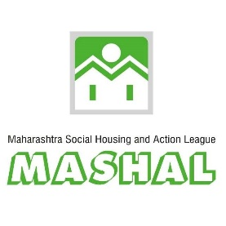
Table of Contents

I. Introduction and Background 2
Project Title 2
Project Objectives 2
Project Areas and Duration 2

II. Survey Methods 2
Data Collection 3
Strengths and Limitations 4
Key Participants 4

III. Key Findings 4
Proposed Support Required 5
Family Income Source 6
Ownership of House 7
MSN Support 8
Other Organization Support 8
Loan Requirement 9

IV. Geo Location and GIS Integration 9
Introduction of GIS 9
GIS Benefits for Survey 9
GIS Integration 9

V. Recommendations 11

VI. Appendices 12
Monthly Plan and Activities 12
MSN Survey Questionnaire 12
Geo Location Collection 15

VII. Survey Photos 15
I. Introduction and background:
In the year 2007, Shri. Shrikant ji Hanmantram ji Rathi of Tarachand Ramnath Seva Trust established. The objective of this trust is to bring social change in a planned manner. The focus on community issues. He devoted his family to charitable works. It was decided to spend 1 anna (6.25%) of the annual income. Taking this tradition forward, Shrimati Geeta Deviji Shrikantji Rathi has created “Mr. Shrikantji - Geeta Devi Rathi Seva Kosh" and she has been formed Mahesh Safety Net.
MSN’s MSN project main purpose is to creating and enabling support system to provide relief to economic crises of Needy families of Pune district Maheshwari community.
MASHAL has approaches to MSN for conducting need assessment survey of Maheshwari community. three months duration project emphasis on to Identifying needy 100 family’s needs of Maheshwari community through need assessment survey. also, MSN will be Assist to MASHAL for identifying new needy families available in the community.
- Project title: “Need Assessment Survey Project-MSN”
- Project Objectives: 1) To identify the needs of 100 families in Maheshwari community through conducting need assessment survey. 2) To collection geographic information and location of families and integrate through GIS mapping.
- Project Area: Proposed project area was PMC ward in Pune city. 100 Maheshwari community families were identified in different locations from Pune PMC ward.
- Project Duration: Three Months

II. Survey Methods:
The need assessment survey was conducted through door to door home visits and face to face interview filling hard copies and online google form questionnaire (https://forms.gle/AYXTaLKY4iGJWe8E8 ). questionnaire for the survey prepared and provided by the MSN to MASHAL. Five sections were formed in the survey form which includes, first section covered information regarding details of head of family, house type, assets and monthly expenses of the family. Section second collects all family members information like income, documents, bank details and disability. Third section analyse the data about government and private schemes benefit and linkages with the family. Section four has analyse the family current status, needs and follow-up required. Fifth section consist loan requirement status and documentation grievance of the family.
- Data Collection:
MASHAL’S staff have been conducted survey by door to door home visit of existing and new identified Maheshwari communities’ families. Existing family’s data provided by the MSN to MASHAL. These data were helps staff to prepared pre planning and reappointment available family members for home visit. Till the date 87 families were survey conducted and 9 closed families location collected. Survey conducted at family’s home area with face to face interview using hard copies and online google form questionnaire. Collected geo location information of all families for GIS through technical device. Also, technical team has given training to staff.
Before the home visit of MSN family’s pre-verification visit has been done by the MSN anchors. Also new identified families home visit jointly conducted by Mashal’s staff and MSN anchors. Staff were taken pre-appointments for daily home visit of MSN families. All the collected data were submitted to the technical team once in a week. MSN family’s needs identified through the conducting face to face meeting, observation and documents verification.
Total three types of list provided to the MSN after need assessment survey conducted and data analysis completed. Firstly, final survey list is submitted that include all the data related to the provided questionnaire. Secondly, summery data sheet which indicates needs and supports required of MSN families. Thirdly, reflects rejected list of cancelled families or rejected families due to various reasons.
- Strengths and limitations:
All the MSN families were actively responded survey and detailed information were provided to us. Most of the families were aware about assessment survey, MSN informed to all Maheshwari families so, we were conducted survey easily without any struggle. Existing MSN families survey list provided by the MSN to MASHAL. In the provided list data was the improper manner. In given list some details were missing like addresses was incomplete, not updated, mobile numbers were not active and not updated. Also, coordination of jointly visit for MSN family pre-verification was poor. Many of the Anchors was not available for the pre-verification of MSN families scheduled joint visit.
- Key participants:
Filed coordinators of MASHAL were collected the data by conducting of MSN families survey. Total 87 families of Maheshwari community were participated survey. It includes both of families which are continued supports given by the MSN and supports discontinued reflects as rejected families.

III. Key Findings:
The findings presented in this report are based on survey data collected over the from field of Maheshwari community families. Five broad need domains are addressed, during need assessment survey Education, Health, Skilling and mentoring, DCT Financial support and Govt. schemes benefits. Several main findings emerge from the analyses of data from need assessment survey of Maheshwari community families.
We are analysing that Maheshwari community families are struggling issues of poverty, emotional disturbing, loneliness, employment etc. Indeed, all of the Needs Assessment reports confirm that mostly families are struggling with multiple needs at once.
67% of the survey respondents are not received different government schemes (Given schemes list) and their benefits. 33% of the survey respondents are received benefits from different government schemes (Given schemes list). some respondents refused information of family annual income they may not have felt comfortable disclosing honestly. But after having a frank discussion with the respondent and his family members then we were got realistic information from them. Most of the respondents were registered their needs i.e. support for medicines, financial support for health treatment, support for children education, need skilling, need counselling, support for business growth and support for government schemes benefits.

Some families are described other needs related to support for legal issues, purchasing own house, start-up for new business, support for grocery and support for loan repayment.

- Proposed support required
87 families were reported that they were required multiple needs at once. Education needs includes educational fees, educational material support for children education. Health related support for medicines, treatment check-ups, surgery of any disease. In skilling and mentoring families required skilling, vocational course, training for employment etc. DCT for regular expenses of purchasing grocery, gas, etc and most of the families required support for receiving government schemes benefits.
- Family income source
Among respondents who belongs to Maheshwari community (41, representing 47% of survey respondents) were report that their main family income source is working with small business.

- Ownership of House
56 family’s respondents (64% of survey respondents) reported that they are living in house on rent basis. And (9; 10% of survey respondents), responded that they are living in relatives’ home without rent.

- MSN support
Out of 87 families MSN has given supports to 62 families with different services for the 6 months to 1-year duration.
- Other organization support
26 families responded that they were helped by other MSN and other organization who is working on supporting to vulnerable families in Maheshwari community.

- Loan requirement
Among the respondents (18, 22% of surveyed respondents) required loans for the different needs
IV. Geo Location and GIS integration
- Introduction of GIS
Surveyors depend on a variety of software and technology to gather existing information, collect new information, analyse data, produce plans, manage projects, and deliver accurate data. Geographic information system (GIS) technology brings this functionality and more to one place, providing a central location to conduct spatial analysis, overlay data, and integrate other solutions and systems. GIS is built on a database rather than individual project files, enabling surveyors to easily manage, reuse, share, and analyse data, saving them time.
- GIS Benefits for Survey
- Increase efficiency.
• Plan effectively for site location.
• Provide decision support.
• Automate tasks.
• Save money.
• Integrate survey projects in a single database.
- GIS Integration
Using with the GIS tools, filed staff were collected geo location of each and every surveyed family. Also collected other required information for the linking with each family home location. GIS technical staff has integrated the collected data with geo location as per the MSN requirement. The integrated GIS data divided in to the two sheets, one is GIS display and another is GIS external link. GIS display includes house unique id, family status, head of family name, address, support duration and family anchor names. In other hand GIS external link opened in new windows with google sheet which incurred data of support required for family, needs, status of supported by MSN, supported by other organization and supported by gov. schemes. Above data and information integrated with the each and every family home location. The output of the file format is the KML file, we can easily access the file on google earth.
Equipped with GIS tools, family anchors quickly determine areas; canopy; local control; road networks; previous established boundaries; and zoning, and other required information. The information is stored and easily accessed to the location of MSN family for reuse with any future projects.
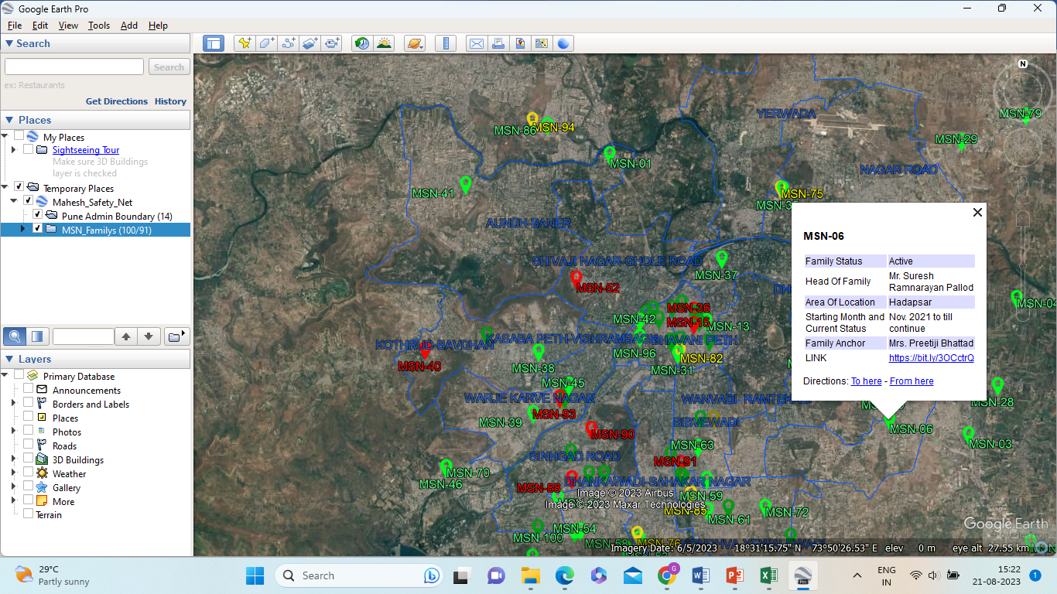
GIS Display- Active Family
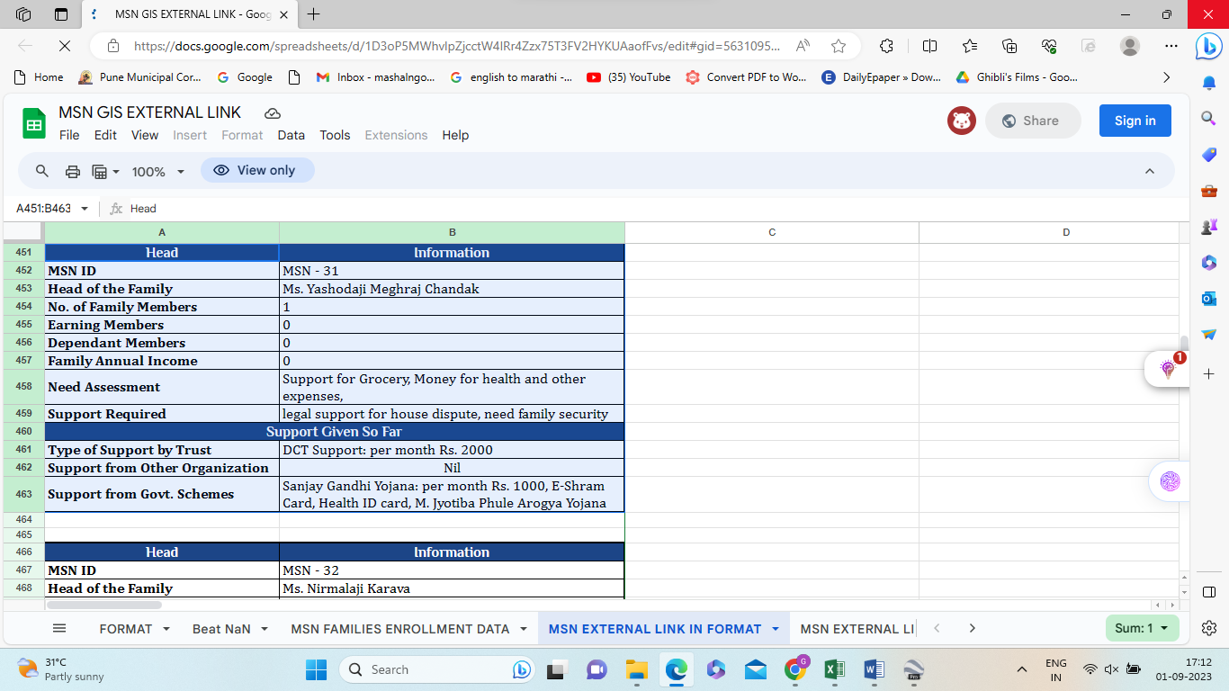
GIS External Link- Active Family

V. Recommendations:
- Prepared the predefined checklist and norms for the analysing and verification of financial status of MSN family.
- Determine the indicators, sub indicators and checklist for the need assessment survey of families in MSN community.
- Some MSN families are not enrolled and rejected by the MSN. Provide the Rejection criteria, verification criteria and checklist for rejection of enrolment in MSN community. Field staff will be analysing and understand about family enrolment and family rejection criteria.
- Specify the capacity and limitations of MSN to accomplish the each and every needs of families. It will be helpful to partner organization for collection of accurate and specific required data.
- Survey takes time longer than planned due to incomplete and not updated data. So complete and updated required data helps time saving and travel cost saving to field staff.
VI. Appendices:
- Monthly Plan and Activities:
Project Manager had overall responsible for the project implementation, monitoring and reporting under the framework of the project. Five field coordinators had responsible for undertaking identified Maheshwari communities’ families’ baseline survey, need assessment survey. During this project period planned activities were conducted through the implementing monthly plan.

- MSN Survey Questionnaire:
Below is the hard copy of questionnaire filled during home visit survey.

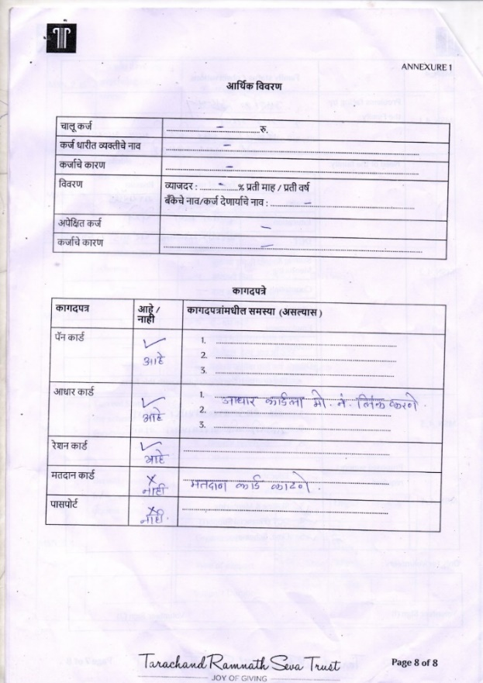
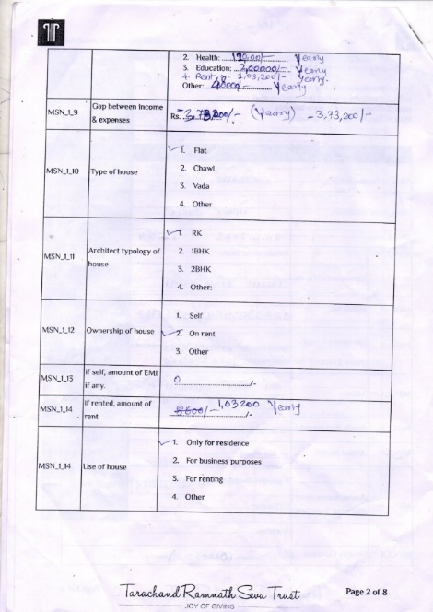
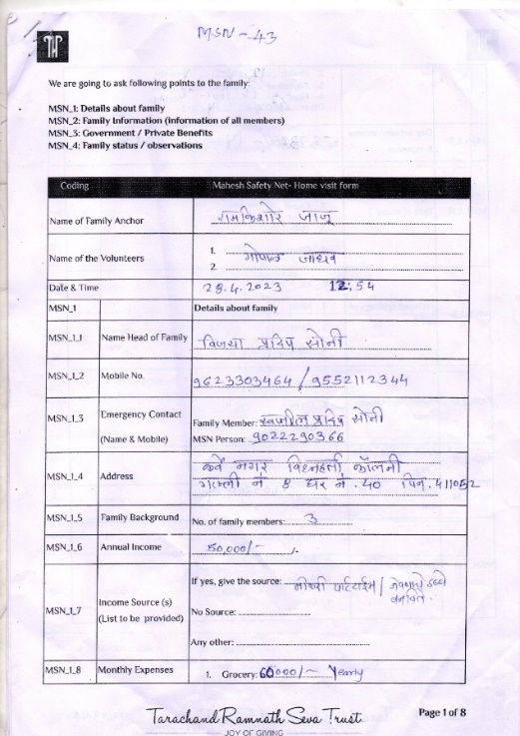
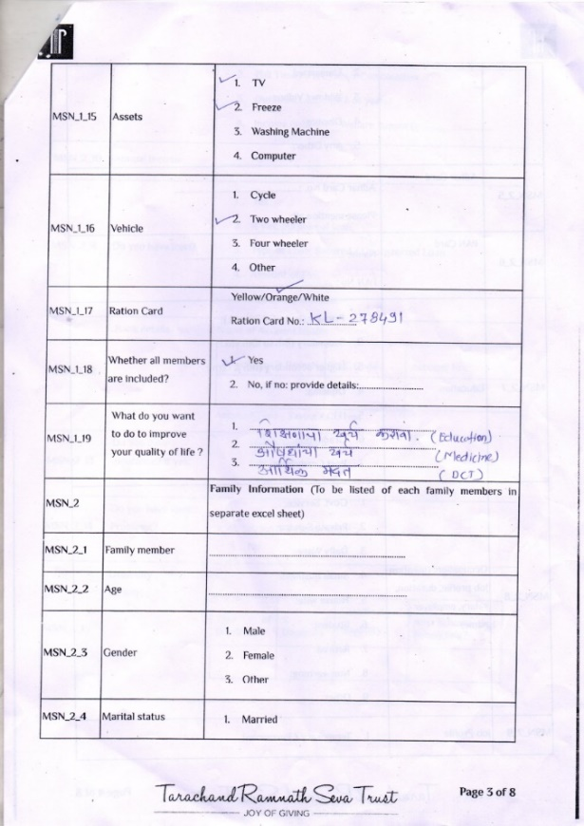
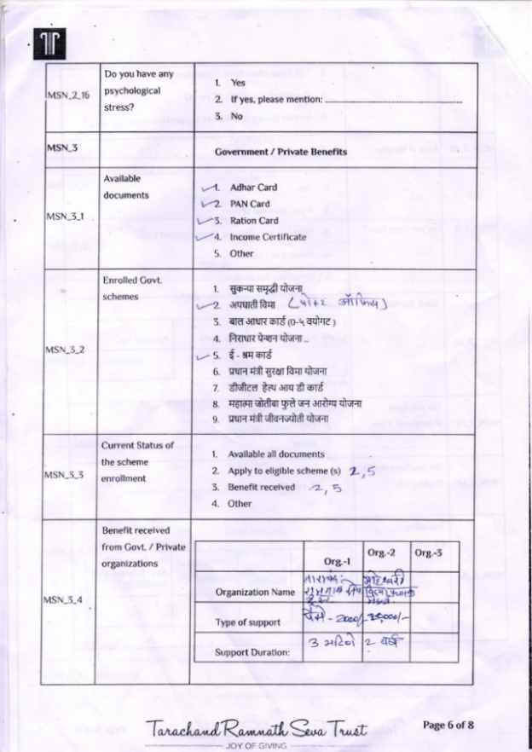
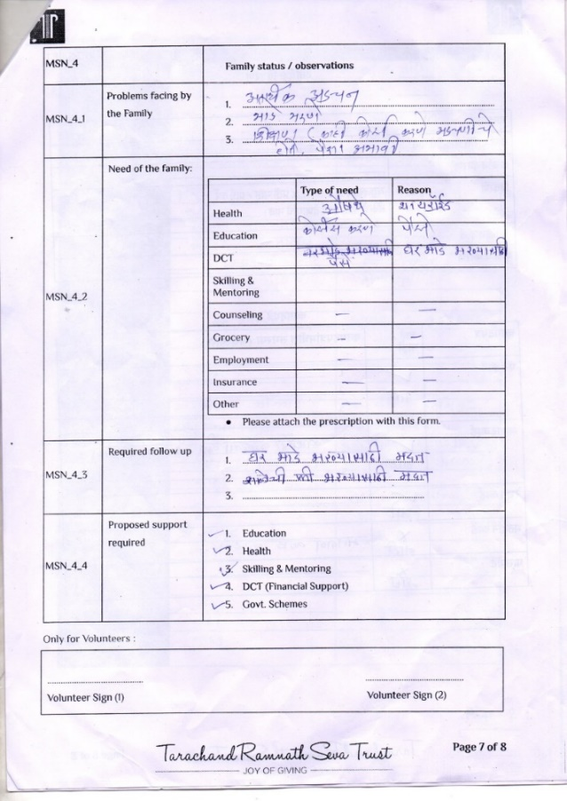

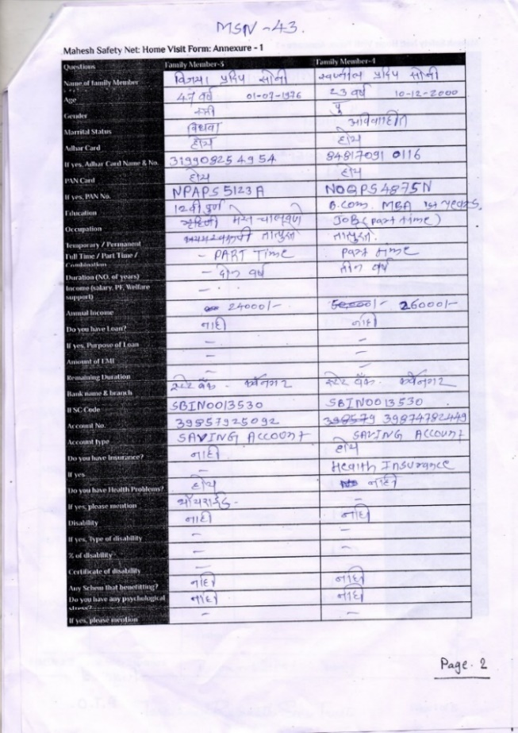
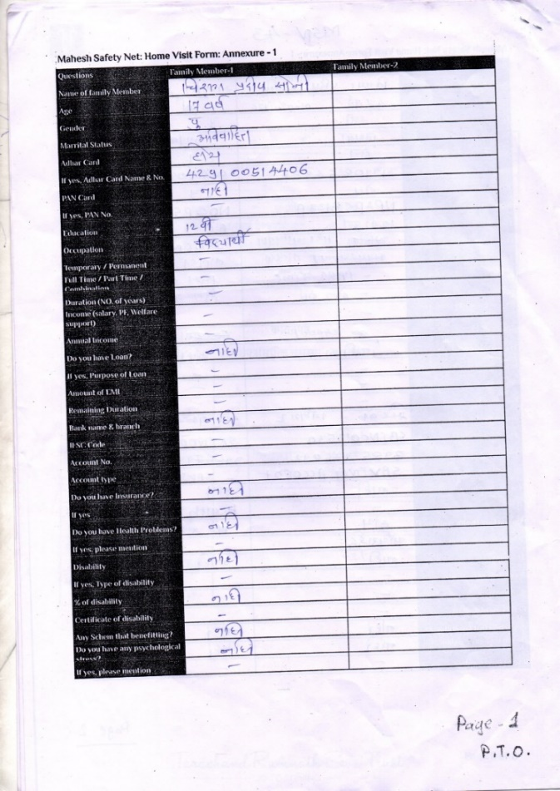

- Geo Location Collection:
Collected geo location information of families through technical device during the home visits.

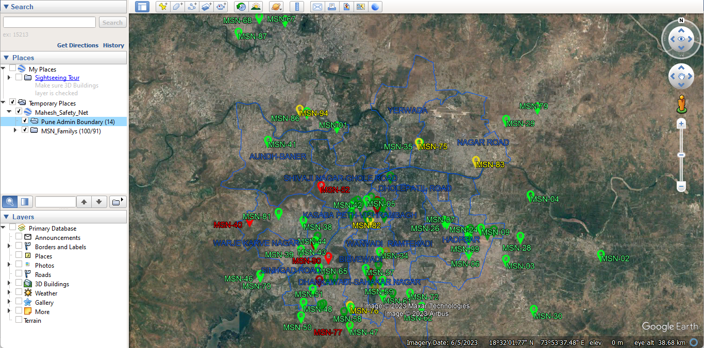

VII. Survey Photos:

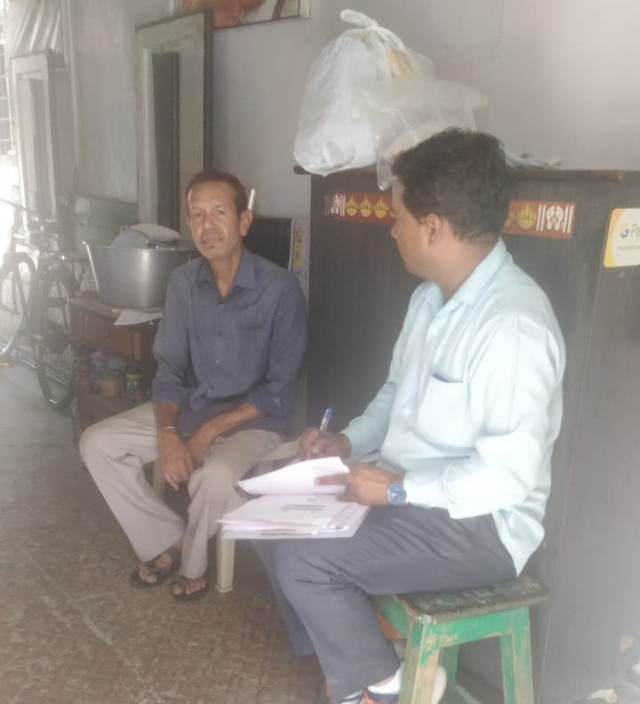
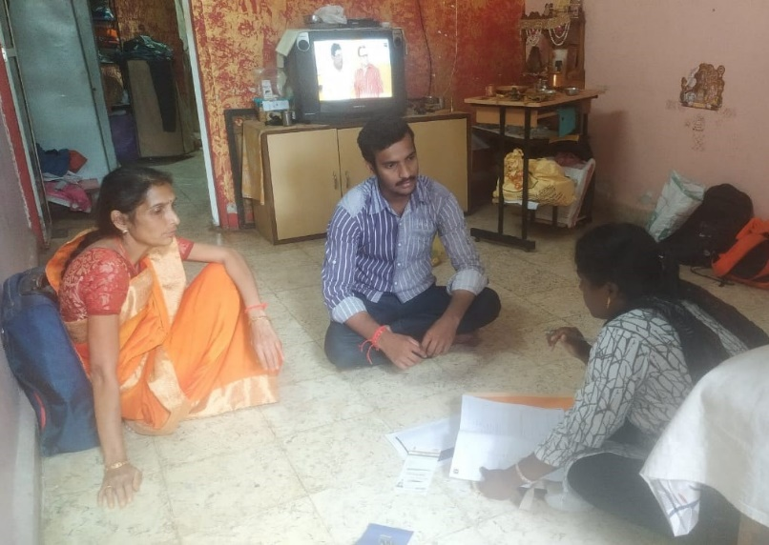
Mr. Vikas Babulal Bang, Narayan Peth
Ms. Vijaya Pradip Soni, Karvenagar

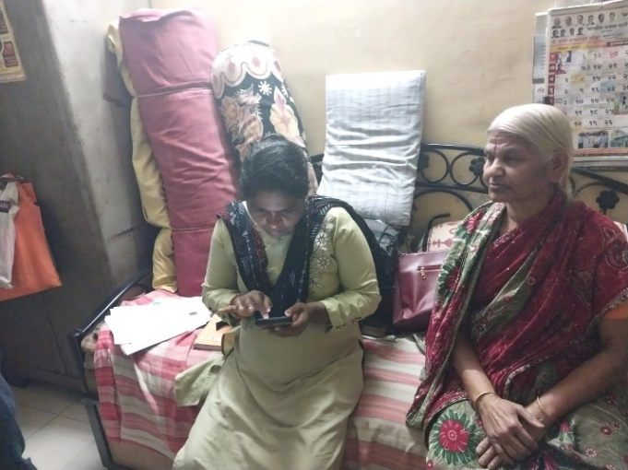
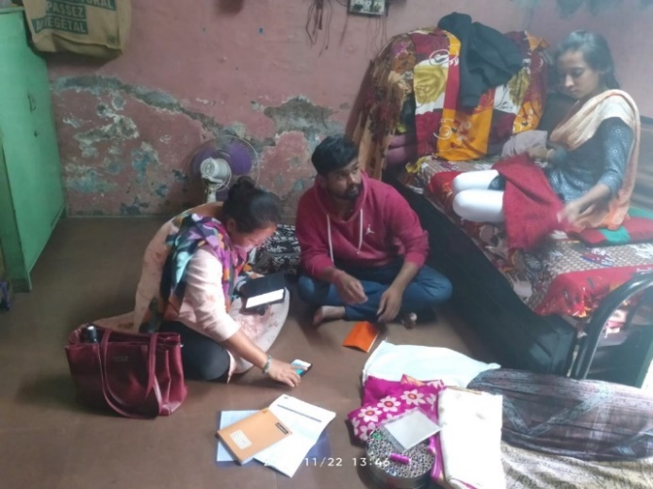
Mr. Bansilal Darak, Shukrawar Peth
Ms. Jyoti Nandkishor Bhutada, Hadapsar

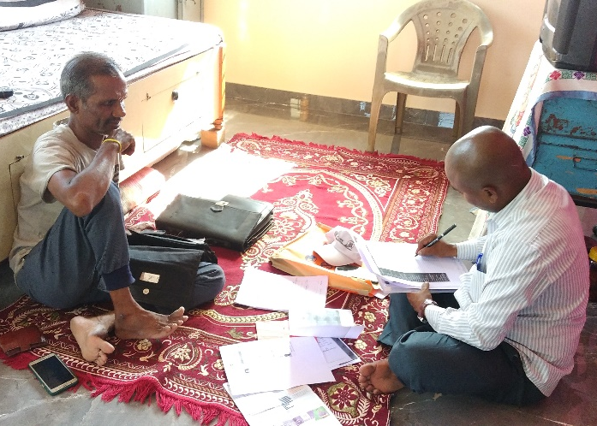
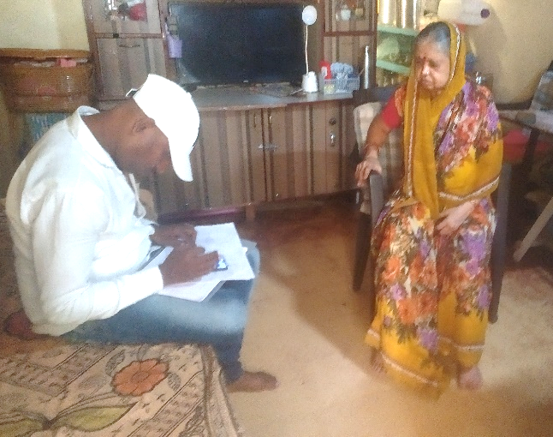

Mr. Dinesh Malu, Loni Kalbhor
Ms. Asha Kiran Jaju, Wagholi

